Credit One data was analyzed using machine to determine algorithms to determine whether or not there were any characteristics that could indicate what rate a person should be approved for credit at. After thoroughly prepping and exploring the data there was very little information to go on that would indicate very much of a correlation between features.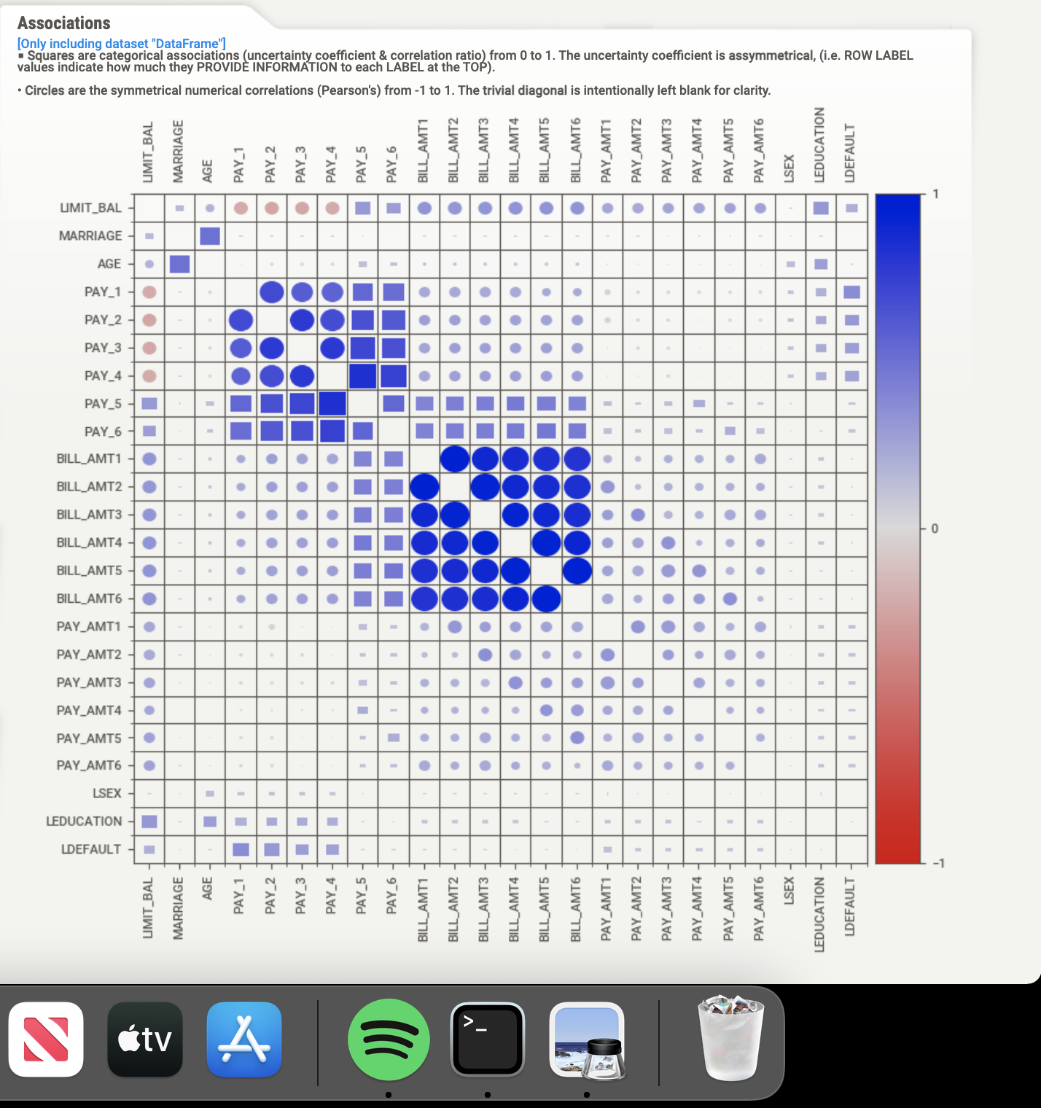

However, when using this correlation chart, we can see som slight correlations between Pay 1 and Default Next Month. There is also a slight correlation between Education and Default Next Month, and a smaller correlation between Limit Balance and Default Next Month although it’s very small. It was difficult to find any other relationships even with graphing programs. The graph below is a scatterplot of Age by Default Next Month, and as you can tell there is no pattern to detect.

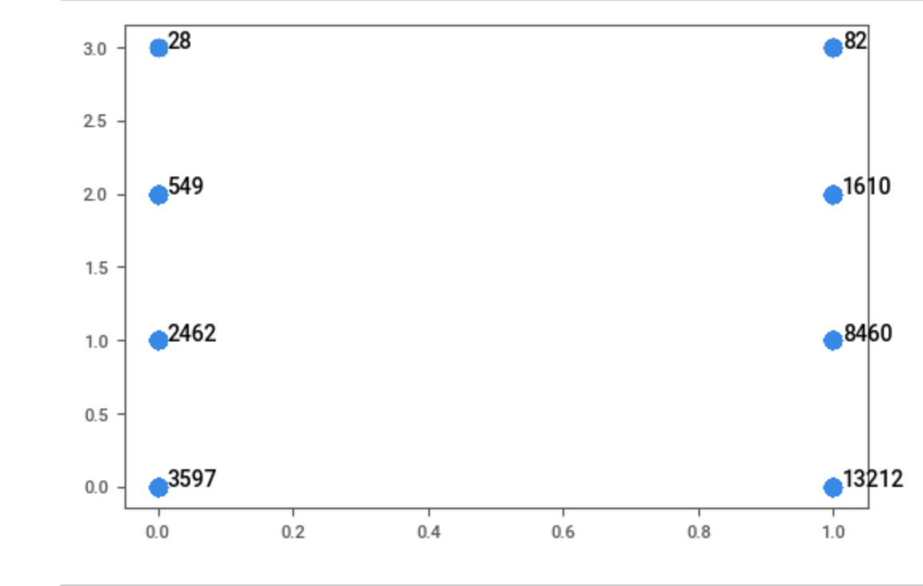

I used the features Age, Limit Balance, Pay1 thru 6, and Education, Sex and set them as my x-variables. I used Default Next Month as my y-values. I then ran the data through 3 different regression models. None of the regression models were able to produce an accurate result with any real reliability. As such, I was unable to determine if there is a limit to the amount that someone should be approved for, or really whether or not someone should be approved at all.

However, I was able to switching to the use a classification algorithm I was able to find something interesting. Using the entirety of the dataset, I am able to determine with 80 percent certainty whether or not someone will be defaulting in the next month. This should be very useful to your business, and having this knowledge should help the company to plan ahead.